Assignment 2
Due: After Unit 5
Total: 100 marks
Weight: 15% of your final grade
Answer all questions in this assignment. Submit your completed work to your Academic Expert for marking and feedback using this Assignment Drop Box.
- (12 marks) Answer the following questions (150 words max/question).
- Using an example, explain how referential integrity is established during the creation of database tables?
Referential integrity is especially important to implement at the creation of database tables. Referential integrity constraints will ensure that all new data inserted into, update, modified, or deleted, must validate the foreign key constraint rule. Newly inserted data must have valid referential data to point to. If a record is deleted, the database will also ensure that no other record may refer to that key. It is much easier to enforce RI at the onset of a table, whereas implementation after data exists may involve cleaning or correcting of existing data.
- Explain the factors that need to be considered for creating an index on a specific table column.
Indexing, when properly used, can be an extremely impactful way to improve the performance of database interactions. Indexes provide the dabase query with information on how data should be sorted, so quick scanning and retrieval can be achieved. The more records that exist within a table, the slower it takes for a database to find desired records. Indexes can speed this process up by indicating which fields are typically used to locate records. Improperly used indexing can also cause the opposite, and slow the performance of a database. When too many indexes exist, they negate the performance gain, as the database engine must search each of the indexes until the criteria is matched. In addition, indexes can consume great deals of storage space, which can impose financial costs as well. Analysis of how a table will be used must be considered when determining which tables to index and how. Indexes can be updated manually, by a schedule or by commits.
- Discuss the difference between triggers and stored procedures.
Triggers and stored procedures are both compiled executable blocks of code that can contain any type or number of SQL commands. Triggers, however, do not receive parameters. They are linked to DML or DDL operations, such as table or data creation, modification, or deletion. Triggers can even fire on events like user logons or manual execution. Depending on the type of trigger, different values are available during execution, for example, if a trigger is BEFORE UPDATE then a variable scope NEW will be available. This allows validation or manipulation of data before, during, or after the triggering event, and can even allow cancellation of the event. Stored procedures, on the other hand, are executed programmatically and support both input and output parameters. They may alter or commit data to database tables or simply perform calculations and return values. The usage and attitudes toward triggers and stored procedures have changed over time, depending on database technology, and both have pros and cons. Triggers can provide clean and centralized maintenance of data‑related operations, but they are not always obvious to a casual observer and can be forgotten if not documented. Historically, business logic was often kept inside the database for portability across interfaces, but more recently the trend has shifted toward keeping only essential storage operations in the database.
- (40 marks) Consider these three relations and then write SQL statements to answer the questions that follow.
TRAVEL_AGENT (TA_no, name, age, salary)
CUSTOMER (C_ID, name, departure_city, destination, journey_class)
TRANSACTION (number, C_ID, TA_no, date, amount_paid)
- Compute the number of different customers who have a transaction.
select count (distinct c_id) from customer c
inner join transaction t on t.c_id = c.c_id
- Display the name of the oldest travel agent.
Select top 1 name from travel_agent order by age desc;
- List the total number of transactions for each travel agent. Consider only those transactions where the amount paid exceeds 1000.
Select count(tx.number), ta.name from transaction tx inner join travel_agent ta on ta.ta_no = tx.ta_no
where tx.amount_paid > 1000 group by ta.name
- Display the names and ages of the travel agents who have arranged journeys for customer “John Smith”, in descending order of age. (Use a subquery.)
Select ta.name, ta.age from travel_agent ta where ta.ta_no in
( select tx.ta_no from transaction tx inner join customer cust on cust.c_id = tx.c_id where cust.name = ‘John Smith’)
Order by ta.age desc
- Display the names and ages of travel agents who have arranged journeys for customer “John Smith”, in descending order of age. (Do not use a subquery.)
Select ta.name, ta.age from travel_agent ta inner join transaction tx on tx.ta_no = ta.ta_no inner join customer cust on cust.c_id = tx.c_id where cust.name = ‘John Smith’ order by ta.age desc
- Display the age of travel agents who have arranged journeys for customer “John Smith” to “Ottawa”. (Use a subquery.)
Select ta.age from travel_agent ta
inner join transaction tx on tx.ta_no = ta.ta_no
inner join customer cust on cust.c_id = tx.c_id
where cust.c_id in ( select c_id from customer where destination = ‘Ottawa’ and name = ‘John Smith’)
- Display the age of travel agents who have arranged journeys for customer “John Smith” to “Ottawa”. (Do not use a subquery.)
Select ta.age from travel_agent ta
inner join transaction tx on ta.ta_no = tx.ta_no
inner join customer cust on cust.c_id = tx.c_id
where cust.destination = ‘Ottawa’ and cust.name = ‘John Smith’
- Display the names and salaries of all travel agents who have not arranged journeys for customer “John Smith”, in ascending order of salary.
Select ta.name, ta.salary from travel_agent ta where ta.ta_no not in
( select distinct ta_no from transaction tx inner join customer cust on cust.c_id = tx.c_id where cust.name = ‘John Smith’)
- Display the names of travel agents who have five or more transactions.
Select ta.name from travel_agent ta
inner join transaction tx on tx.ta_no = ta.ta_no
group by ta.ta_no, ta.name
having count(tx.number) >= 5
- Display the names of all travel agents who have arranged at least ten journeys to “Ottawa”.
Select ta.name from travel_agent ta
inner join transaction tx on tx.ta_no = ta.ta_no
inner join customer cust on cust.c_id = tx.c_id
where cust.destination = ‘Ottawa’
group by ta.ta_no, ta.name
having count(tx.number) >= 10
- (8 marks) Consider the following Realtor database with three relations. Write SQL statements for creating a view called AgentsOfTheYear that will display the name and address of realtors who have sold a total amount of 5 million dollars’ worth of properties in 2021.
RealtorAgent (realtor_no, name, age, address, commission_percentage)
Customer (C_ID, name, property_id, property_address, description, property_tax, property_value)
Transaction (realtor_no, C_ID, property_id, price_sold, date_sold)
Create or replace view AgentsOfTheYear as
SELECT ra.name, ra.address
from RealtorAgent ra
inner join transaction tx on tx.realtor_no = ra.realtor_no
where extract(year from date_sold) = 2021
group by tx.realtor_no, ra.name, ra.address
having sum(tx.price_sold) > 5000000
- (10 marks) Consider the following relations:
Student (student_no, name, address, GPA)
Course (course_no, title, texbook)
Instructor (instructor_no, name, phone_no, specialization)
Registration (student_no, course_no, instructor_no, session)
Qualified_to_teach (instructor_no, course_no)
- Determine the relationships among these relations. List the primary keys for each relation and any foreign keys necessary to establish the relationships and maintain referential integrity.
- Student:
  - Primary key: student_no
  - Foreign keys: none
  - Relationships:
    - Student (one) to (many) Registrations
- Course:
  - Primary Key: Course_no
  - Foreign Keys: None
  - Relationships:
    - Course (one) to (many) Qualified_to_teach
    - Course (one) to (many) Registration
- Instructor:
  - Primary Key: instructor_no
  - Foregin Keys: none
  - Relationships:
    - Instructor (one) to (many) Registration
    - Instructor (one) to (many) Qualified_to_teach
- Registration:
  - Primary Key:student_no, course_no, instructor_no, session
  - Foreign Key:
    - student_no -> student.student_no
    - course_no -> course.course_no
    - instructor_no -> instructor.instructor_no
  - Relationships:
    - Registration (many) to (one) Student
    - Registration (many) to (one) Course
    - Registration (many) to (one) Instructor
- Qualified_to_teach:
  - Primary Key: Instructor_no, course_no (composite)
  - Foreign Keys:
    - instructor_no -> Instructor.instructor_no
    - course_no -> Course.course_no
  - Relationships:
    - Qualified_to_teach (many) to (one) Instructor
    - Qualified_to_teach (many) to (one) Course

- Write SQL query to list the names of instructors who have taught COMP 378 but not COMP 418 during the following sessions: Winter 2020 and Winter 2021.
Select ins.name from Instructor ins
inner join registration c378Reg on c378Reg.instructor_no = ins.instructor_no
inner join course c378 on c378.course_no = c378Reg.course_no
where c378.title = ‘COMP 378’ and
( c378Reg.session in (‘Winter 2020’, ‘Winter 2021’ ))
and NOT EXISTS
(
select 1 from Registration regEx
inner join Course cEx on cEx.course_no = regEx.course_no
where regEx.instructor_no = ins.instructor_no AND
cEx.title = ‘COMP 418’ and
( regEx.session in (‘Winter 2020’, ‘Winter 2021’ ))
)
- (16 marks) Answer the following questions (250 words max/question).
- Discuss the distribution of application logic components across clients and servers in the client/server environment.
- Application logic components are one part of three that make up a three tier application architecture. A three tier application is comprised of presentation layer, application logic layer, then storage layer. The presentation layer is what the user sees and interacts with. The application logic layer is the main intelligence of a system. Its where data is manipulated, decision making, or validations are enforced. The behaviours and activities of the application is maintained here. The storage layer is responsible for storing and retrieval of the data.
- Client/server environments describe a software architecture where the system is split into two separate parts; client and server. The client is the layer is the interface that the user interacts with. The server is the layer that the client connects to and provides the storage and logic layers.
- There are two client server types; thin client or fat client. Thin client is where the interface is hosted outside of the users environment. The benefit of this is the system is hosted centrally, which means access, provisioning and troubleshooting much easier, it also means minimal software needs to be installed on the users computer. Fat clients are where a majority of the system are installed on users computers.
- Thin clients impost greater resource demands on central systems, as they must provide storage, and processing for all users who connect to the system. Centrally deployed software is much easier to manage and maintain, ensure consistent versioning and to control access.
- What are the most important security features for data management software?
- The most important security features of a data management software includes limiting access to schemas or viewing of data, enforcement of database objects, integrity constraints, checks of a relational database system, authorization rules to ensure users may only permit their assigned actions, ensuring user defined functions, constraints and objects are executed or triggered properly, encryption and data protection is used, authentication to ensure the user attempting to access the resource is properly identified and backing up and journaling of data.
- What threats to data security must be addressed in a comprehensive data security plan?
- Threats to data security include: accidental loss of data, theft or fraud, loss of privacy or confidentiality, loss of data integrity and loss of availability.
  - Accidental loss of data could be a result of hardware or software failure or human error. Special steps must be taken to protect against these such as user authorization, software or hardware maintenance and controls and other policies.
  - Theft or fraud are caused by people to access, alter information or damage infrastructure. Physical and electronic controls must be used to prevent unauthrozied persons to gain access to physical locations or firewalls to prevent inappropriate connections.
  - Loss of privacy or confidentiality means loss of protection of dataor loss of protection of critical organizational data. This can lead to blackmail, bribery, embarassement, stolen passwords or more. Laws exist that require companies to communicate policies to ensure protection of data, or notify users of possible exposure.
  - Loss of availability is when an application becomes unavailable to users, which can lead to several operational difficulties. It is typically caused by sabotage of hardware, network or applications. Loss of availability an be caused by viruses, so virus protection is important to implement and keep up to date. Intentional attacks or software bugs can also lead to loss of availability.
  - Special security measure must be taken to prevent SQL injection attacks, that is where a user will purposely disguise or inject commands to expose or modify data, or cause damage to the database server.
  - Proper authentication is important, to ensure role based activities and permissions are enforced as well as tracking each action for future audting of activities.

- What is the difference between shared locks and exclusive locks?
Locking is the process of blocking or denying access to any data until a transaction has been completed. Locks can be applied at a variety of different levels; database, table, block (or page), record, or field. These locks can be one of two types; either a shared lock or an exclusive lock. A shared lock is where multiple processes may read from a piece of data, however updating of it is limited to one process at a a time, while reading is permitted by many.
Exclusive locks are locks that prevent any other process from reading or updating from data
Both locks have their purposes, however shared locks are more appropriate for high availability multiple user system, because it allows increases available of data since only updates are affected by the lock. Exclsuvie locks however limit all types of activity to a data including read and update actions.
- (6 marks) Consider the concurrent execution of the following transactions. List two problems that may occur from the concurrent execution of these two transactions.
T1 | T2 | Issue
Read A | Read B
Read B | Write A
Write C | Read C | Dirty read on C
Write A | Write B | Lost update on A
Commit | Commit
(8 marks) Consider the two application environments represented in Figure 1 and Figure 2. Identify the various security considerations that are relevant to each environment.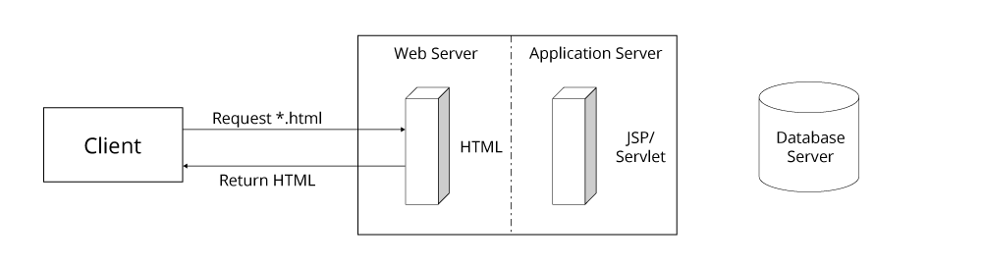
Figure 1: Static page request
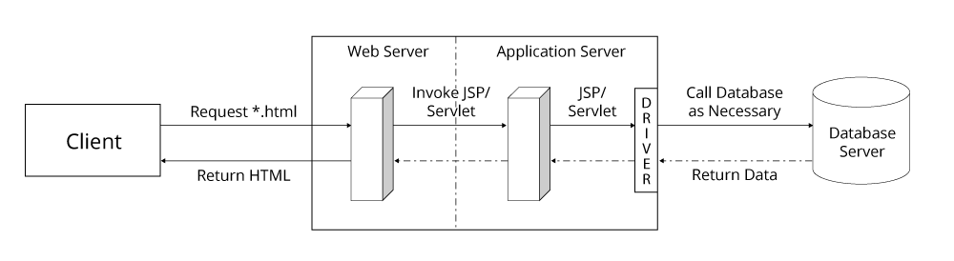
Figure 2: Dynamic page request
Static page request
- Static pages are rendered from precompiled or predetermined web content. The content is unchanging and is usually read from a non-voltile storage mechanism, like a harddrive. The site contents is read into fast access memory and served to users as requested.
- Since the content is established before being published on the web server, there is no need for application server, or database server in this environment. This allows a complete isolation of the webserver, even permitting air-gapping from other servers.
- The webserver should only respond to request for static web pages, any other type should be rejected or redirected.
- Static web servers require far less hardware than those of dynamic page content servers.
Dynamic page request security concerns
Web Server:
- In the event that any dependency of the Web Server, including the Application Server, database driver, or Database Server are unavailable, there should be no negative impact on the servers resources, availability or performance.
- Web servers must also validate against the types of requests like static pages, however the file extension filter may expand to include additional types, as requests may be passed through from website to application server.

Application Server
- Application server must only accept incoming connections from the webserver via accepted protocol or port. No other connections should be permitted unless absolutely necessary.
- Application server must authenticate the webserver to ensure the webserver is who is making the connection
- Depending on the application, some web servers may use impersonation as a form of authentication, meaning the client credentials provided from the client are then passed to the application server, further ensuring that system resources are used only by authorized individuals.
- All actions should be logged for troubleshooting and auditing purposes.
- The server must contain its own protections to ensure that the code being executed on the server does not access any resources outside of its domain, or can improperly use. Improper code, either intentional or accidentally, can cause information to be damaged or released, physical damage to hardware, reduction of availability or consumption of one or all available resources of the server

Database Server
- Network filters should be put in place to only allow connections from the Application Server, this can be done using IP or MAC address filtering.
- The database server must authenticate the user attempting to connect to the database server, as well as ensure that user does not access any resources, objects, or data that they should not have access to.
- All connection activities, regardless of outcome, must also be logged
- The database server should have a regularly scheduled backups and restore schedules, with emergency recovery and crisis mitigation plans

Common Security Concerns
In addition to those specific environment security measures, both should employ security measure like these:

All
- All servers contain software and most hardware. Proper maintaince of hardware and software is a very important security measure. Software updates can patch security bugs as their identified, or prevent virus attacks. Hardware components also require maintenance; cleaning, lubrication of moving parts, replacement of failed or expired hardware etc.

Client
- Authentication / Authorization: Depending on the nature of the client, there may be authentication and authorization applied to the client. This could be in the form of network domain authentication, form based login, cookie or token authentication and more.

Web Server
- Incoming requests may have network filtering rules applied: connections may be limited or denied to due IP address, IP address ranges, MAC address, authentication, frequency of connections (DDos protection), recognized request paths / routings, URL injection and more. Special protection against scraping or crawling activities may also be taken.
- Web servers may always request the client authentication to protect resources, data or functionality against unauthorized access
- The webserver must provide secure socket layer protection, by employing SSL certificates. This will provide the client with assurances that the web server is who is claims to be, and that all data transmitted between server and client are properly encrypted and cannot be intercepted.
- Web servers should maintain regular backups, consistent software updates and ideally operate in an environment where recovery or restarting of services can be completed quickly. Ideally web servers would be scalable and able to respond to client demand
- Strict logging of all requests and performance must be enforced
- Availability, performance and telemetry should also be considered, as it can provide proactive identification of nefarious users.

